SIMATS ENGINEERING
ASSESSMENT TOOL 2

COURSE NAME: INTERNET PROGRAMMING
COURSE CODE: CSA43

COURSE OUTCOME COVERED

CO-1: Develop well-structured, standards-compliant web pages using HTML/XHTML and XML, and apply Internet protocols and HTTP communication mechanisms for web content delivery. (L2)

Assessment Tool : Data Interpretation

Weightage: 20%

QUESTIONS: Total Marks: 20

1: HTTP Response Analysis
A web server returns the following HTTP response header:
HTTP/1.1 200 OK
Date: Mon, 01 Apr 2026 10:00:00 GMT
Content-Type: text/html
Content-Length: -150
Connection: keep-alive
Questions:
- Identify any incorrect or invalid fields in the header.
- Analyze the issue with Content-Length and explain its impact.
- Determine whether the status code matches the response correctness.
- Suggest corrections for the identified errors.
2: DOM Structure Analysis
Consider the following DOM tree representation:
<html>
<head>
<title>Test Page</title>
</head>
<body>
<div>
<p>Hello World
</div>
</body>
</html>
Questions:
- Identify missing or improperly closed elements.
- Analyze how the browser will interpret this structure.
- Determine the impact on rendering and layout.
- Suggest corrections to make the DOM valid.
3: GET vs POST in Login System
A login system uses two different methods:
Method | URL Example | Data Visibility | Security Level
GET | /login?user=admin&pass=1234 | Visible in URL | Low
POST | /login | Hidden in body | Moderate
Questions:
- Interpret the differences in data transmission between GET and POST.
- Analyze which method is more suitable for login and why.
- Identify security risks in using GET for authentication.
- Suggest best practices for secure login implementation.
4: HTML Code Inspection
Analyze the following HTML snippet:
<!DOCTYPE html>
<html>
<head>
<title>Sample</title>
</head>
<body>
<h1>Welcome
<p>This is a paragraph
<img src="image.jpg">
</body>
</html>
Questions:
- Identify missing closing tags.
- Analyze issues with the <img> tag.
- Determine how browsers will handle these errors.
- Suggest a corrected version of the code.
5: Browser-Server Communication Flow
The following sequence describes a web request:
- User enters a URL in the browser
- DNS lookup occurs
- HTTP request is sent
- Server processes request
- Response is returned
- Browser renders page
Questions:
- Interpret each step in the communication flow.
- Identify where delays can occur.
- Analyze the role of DNS in the process.
- Suggest optimizations to improve performance.

Code of Conduct:

I ____V.Dimpu Spandana(192311065)____________ (Name / Reg No) certify that this submission is my original work and that I have adhered to the guidelines specified for this assessment.
I understand that any violation of academic integrity rules will result in disciplinary action.

Signature of the student: spandana

RUBRICS FOR CALCULATION:

Criteria | Weightage | Level 4 (Exemplary) | Level 3 (Proficient) | Level 2 (Developing) | Level 1 (Beginning)
Understanding of Data | 25% | Accurately interprets all data patterns, trends, and relationships | Interprets data correctly with minor gaps | Partial understanding; misses key trends | Misinterprets or fails to understand data
Analysis | 25% | Provides deep analysis with strong logical reasoning and justification | Provides reasonable analysis with some justification | Basic analysis with weak reasoning | No meaningful analysis provided
Application of Concepts | 20% | Effectively applies relevant concepts/tools to interpret data accurately | Applies concepts with minor errors | Limited application; requires guidance | Unable to apply concepts to data
Conclusion | 20% | Draws clear, meaningful conclusions with strong insights and implications | Provides valid conclusions with moderate insights | Conclusions are vague or weak | No clear or valid conclusions
Clarity | 10% | Presents interpretation clearly using proper structure, visuals, and terminology | Generally clear with minor issues | Lacks clarity or proper structure | Poor presentation and difficult to understand

1 OUTPUT: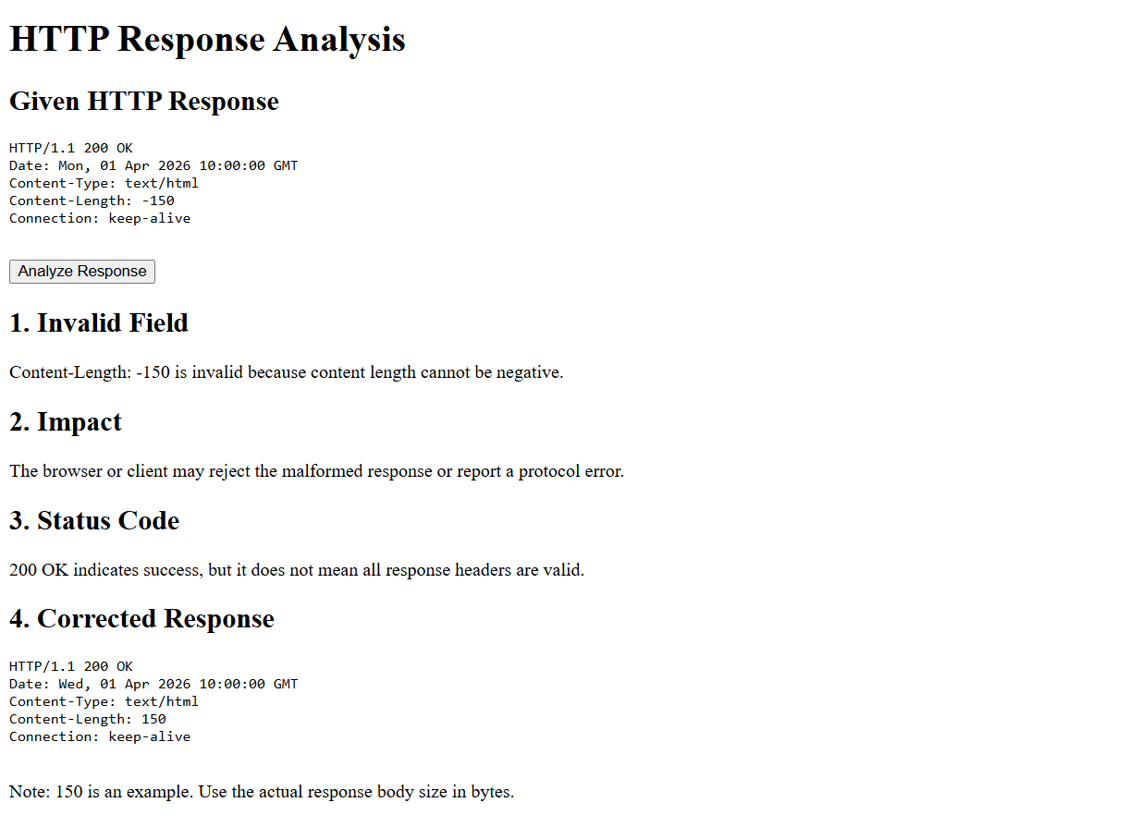

2.OUTPUT
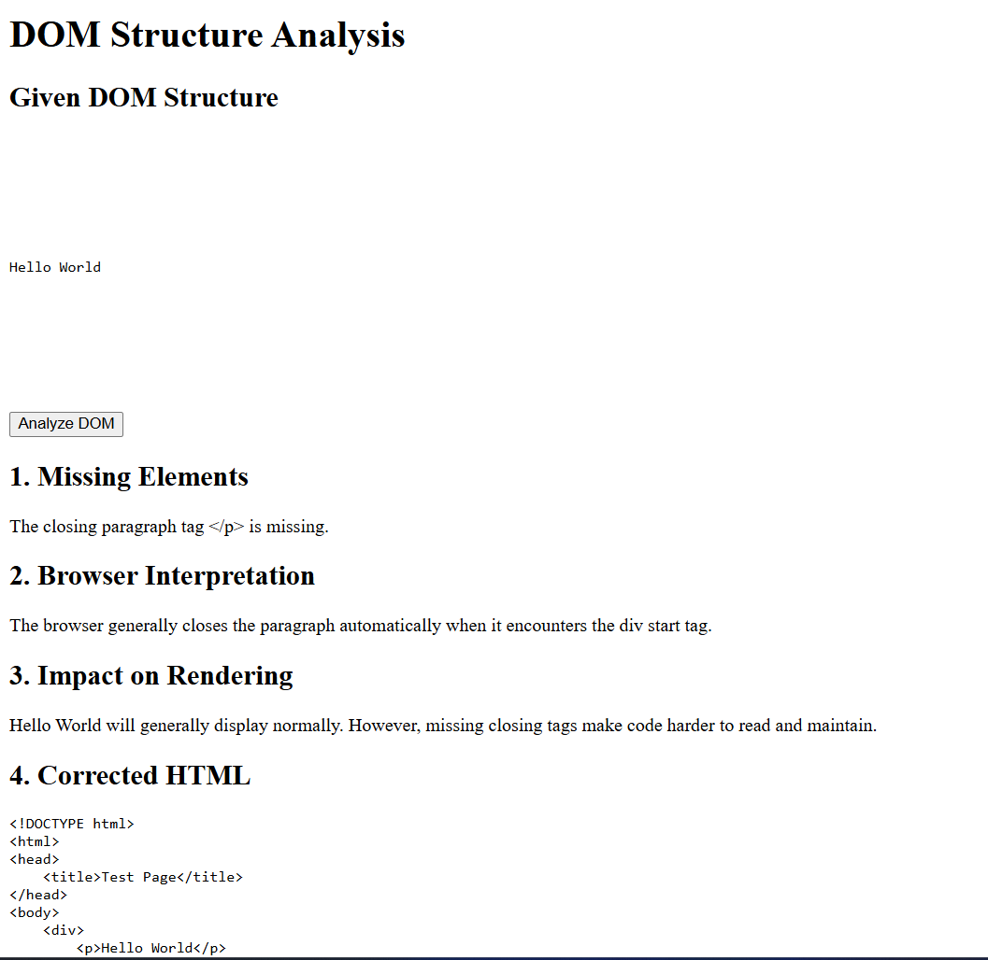
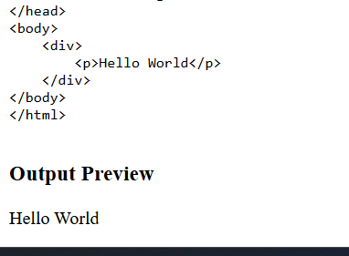
3.OUTPUT
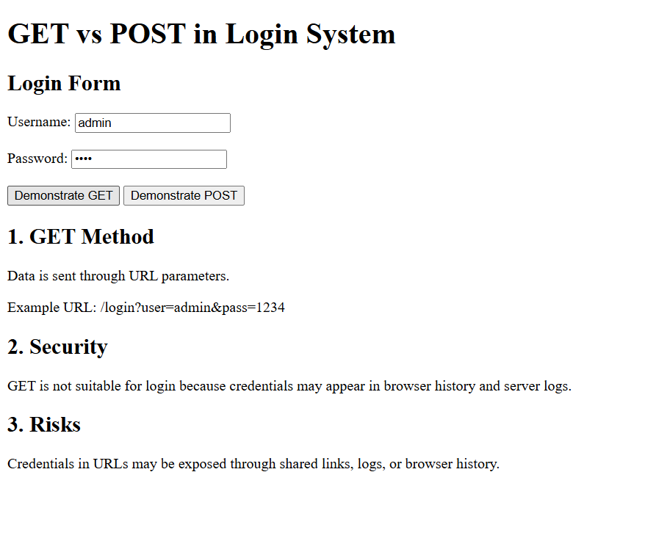
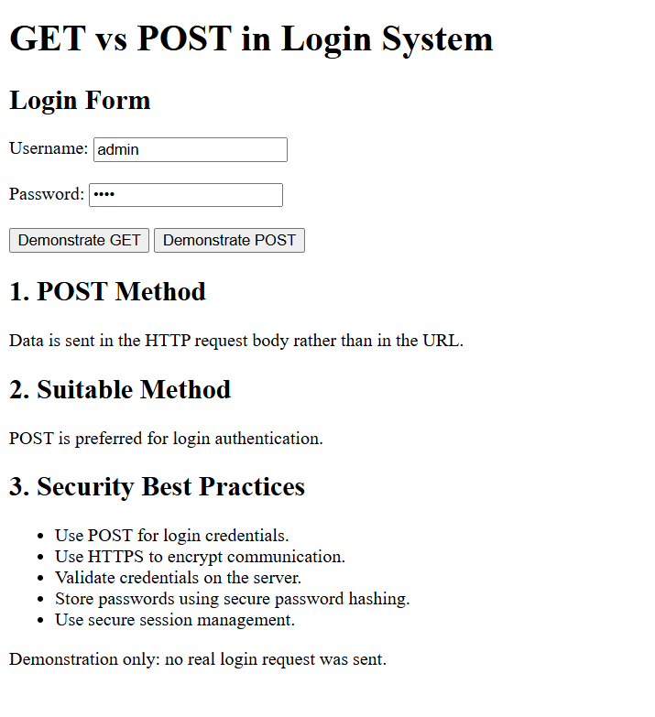
4.OUTPUT
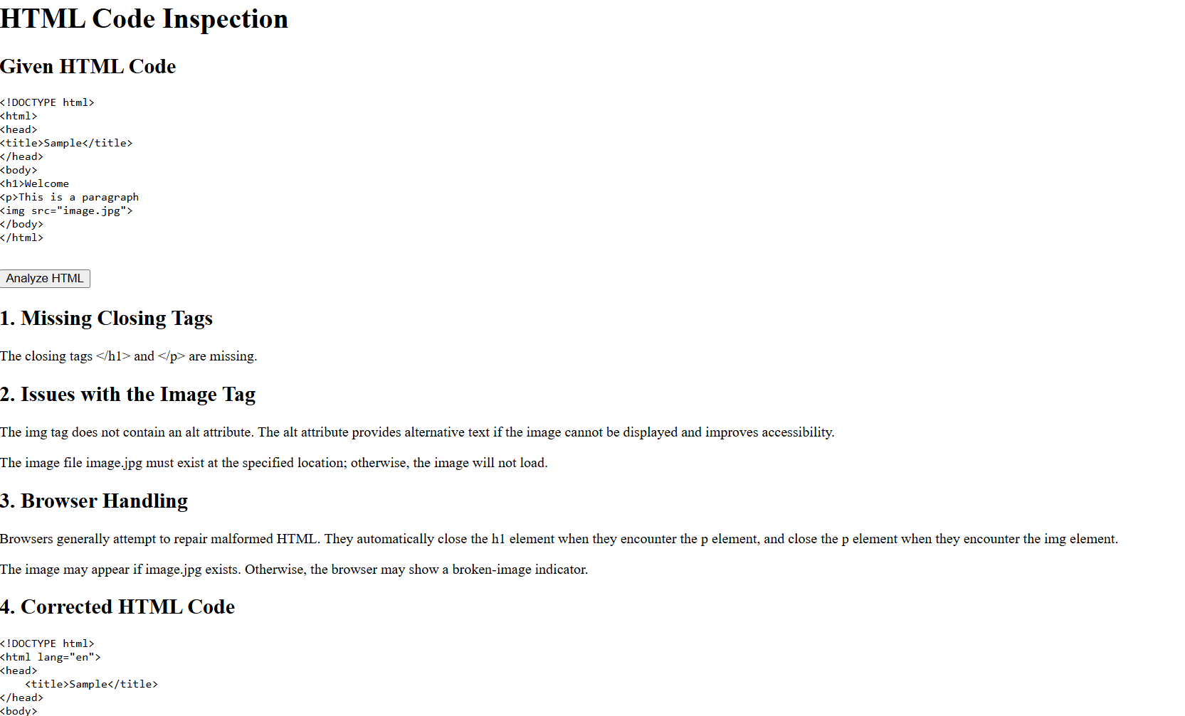
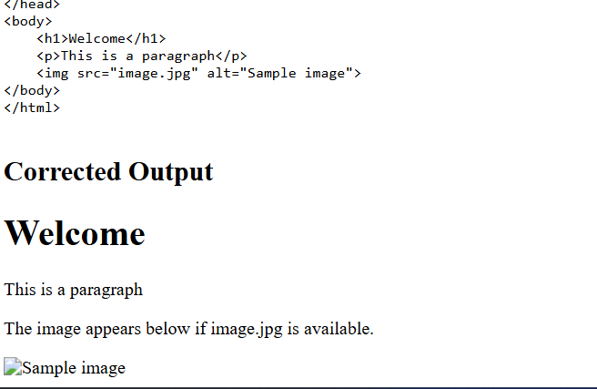

5.OUTPUT
